

**Department of Software Engineering**

**Faculty of Computer Science & Information Technology**

**The Superior University, Lahore**

**Name:** MUHAMMAD HAMZA ALI

**Roll No:** SU92-BSAIM-S24-032

**Section:** 3A

**Subject:** ARTIFICIAL INTELLIGENCE(LAB)

**Task No:** Lab-Task 4(Task-3)

**Task-4**

**Sort Text**

**1. Introduction:**

The purpose of this task is to develop a Python program that sorts words in a given text input into alphabetical order. The implemented solution follows an insertion sort approach for arranging words while maintaining case insensitivity.

**2. Features:**

* Accepts a user-provided text input.
* Splits the text into words and sorts them alphabetically.
* Uses an insertion sort algorithm for sorting.
* Maintains case insensitivity during sorting.
* Outputs the sorted text in readable format.
* Handles basic text input without punctuation or special character.

**3. Implementation Details:**

The program is encapsulated within a call Word_sort, which takes an input string and processes it through a sorting function sort_text(). The sorting function employs an insertion sort algorithm to order the words alphabetically.

**4. User Interaction:**

* The insertion sort approach is efficient for small input sizes but could be optimized using Python’s built-in-sorting function (sorted()) for larger text inputs.
* The program currently does not handle punctuation, special characters, or multiple spaces between words.
* Implementing unit tests would help validate the correctness of the sorting function with different test cases.

**5. Output:**

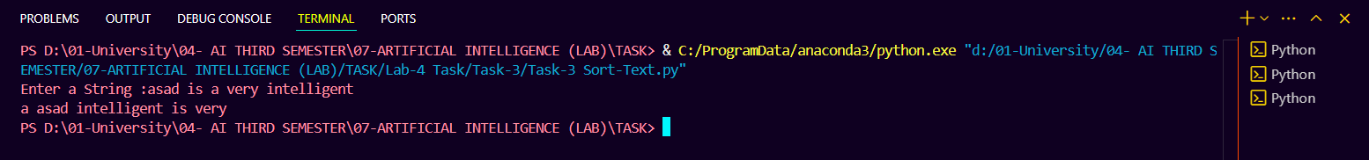

**6. Conclusion:**

This task successfully demonstrates how to sort words in a text input alphabetically using a custom sorting method. Future improvements can optimize efficiency and robustness by refining input processing and considering edge cases.